**Name- Yash Chandra**

**Section- E**

**Class Roll Number-62**

**University Roll Number-2014954**

**Subject Code- PCS-693**

**Subject Name- Web development Lab**

**Assignment Number- 01**

**Question-1** **Create a Simple Admission Form for University admission.**

**Answer-1**

**Code-**

<!doctype html>

<html>

<head>

<title>

Graphic Era

</title>

</head>

<body>

<h1 align= "center"> Graphic Era Deemed To Be University, Dehradun</h1>

<center><img src="download.jpg" alt="Graphic era logo" height="150" width="150"></center>

<h2 align="center"> Admission Form </h2>

<label>Date:</label>

<input type="date"> <br>

<br>

<label> Form Number: </label>

<input type = "number"><br>

<br>

<p><b>Course Details</b></p>

<p> Enter the Course you want to Apply </p>

<label> Course:</label>

<input type="text"><br>

<br>

<label> Branch:</label>

<input type="text"><br>

<br>

<label> College Location:</label>

<input type="radio" id="a8" name="location">

<label for="a8">Dehradun</label>

<input type="radio" id="a9" name="location">

<label for="a9"> Bhimtal </label>

<br>

<p> <b>Student's Details</b></p>

<lable>Name:</label>

<input type="text"><br>

<br>

<label>Gender:</label>

<input type="radio" id="a5" name="gender">

<label for="a5"> Male </lable>

<input type="radio" id="a6" name="gender">

<label for="a6"> Female</label>

<input type="radio" id="a7" name="gender">

<label for="a7">Decline to Answer</label><br>

<br>

<lable>Father's Name:</label>

<input type="text"><br>

<br>

<lable>Mother's Name:</label>

<input type="text"><br>

<br>

<lable>Student Phone Number:</label>

<input type="number"><br>

<br>

<lable>Email ID:</label>

<input type="text"><br>

<br>

<lable>Father's Number:</label>

<input type="number"><br>

<br>

<lable>Mother's Number:</label>

<input type="number"><br>

<br>

<lable>Date Of Birth:</label>

<input type="date"><br>

<br>

<label>State:</label>

<input type="text"><br>

<br>

<label>City:</label>

<input type="text"><br>

<br>

<label>Address:</label>

<input type="text"><br>

<p> <b> Education Details of the students</b></p>

<p><b> 10<sup>th</sup>Details:</b></p>

<lable id="a1"> 10<sup>th</sup> Class Board :</lable>

<input type="radio" id="a1" name="board">

<label for="a1"> CBSE </label>

<input type="radio" id="a2" name="board">

<label for="a2"> ICSE </label>

<input type="radio" id="a10" name="board">

<label for="a10"> Any Other Board</label>

<br>

<br>

<label>10<sup>th</sup> % :</lable>

<input type="number"><br>

<br>

<label> School Name:</label>

<input type="text"><br>

<br>

<label> 10<sup>th</sup> Subjects:</label>

<input type="checkbox" id="b1">

<label for="b1"> English </label>

<input type="checkbox" id="b2">

<label for="b2"> Hindi </label>

<input type="checkbox" id="b3">

<label for="b3"> Mathematics </label>

<input type="checkbox" id="b4">

<label for="b4"> Science </label>

<input type="checkbox" id="b5">

<label for="b5"> Social Science</label>

<input type="checkbox" id="b6">

<label for="b6"> Foundation of IT </label>

<p><b> 12<sup>th</sup>Details:</b></p>

<lable id="a3"> 12<sup>th</sup> Class Board :</lable>

<input type="radio" id="a3" name="board">

<label for="a3"> CBSE </label>

<input type="radio" id="a4" name="board" >

<label for="a4"> ICSE </label>

<input type="radio" id="a11" name="board">

<label for="a11"> Any Other Board</label>

<br>

<br>

<label> 12<sup>th</sup> % : </label>

<input type="number"><br>

<br>

<label> School Name :</label>

<input type="text"><br>

<br>

<label> 12<sup>th</sup> Subjects:</label>

<input type="checkbox" id="c1">

<label for="c1"> English </label>

<input type="checkbox" id="c2">

<label for="c2"> Physics </label>

<input type="checkbox" id="c3">

<label for="c3"> Chemistry </label>

<input type="checkbox" id="c4">

<label for="c4"> Biology </label>

<input type="checkbox" id="c5">

<label for="c5"> Mathematicsthe</label>

<input type="checkbox" id="c6">

<label for="c6"> Information Pratice </label>

<input type="checkbox" id="c7">

<label for="c7"> Work Experience </label>

<input type="checkbox" id="c8">

<label for="c8"> Health & Physical Education </label>

<input type="checkbox" id="c9">

<label for="c9">General Studies</label>

<br>

<br>

<form>

<input type="button" value= "Sumbit">

</form>

</body>

</html>

**Output-**

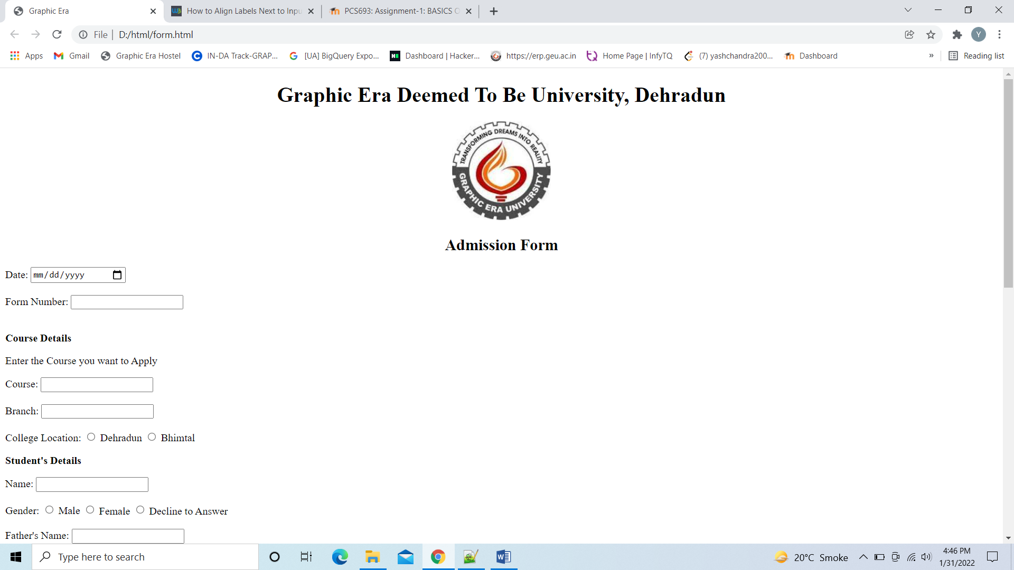

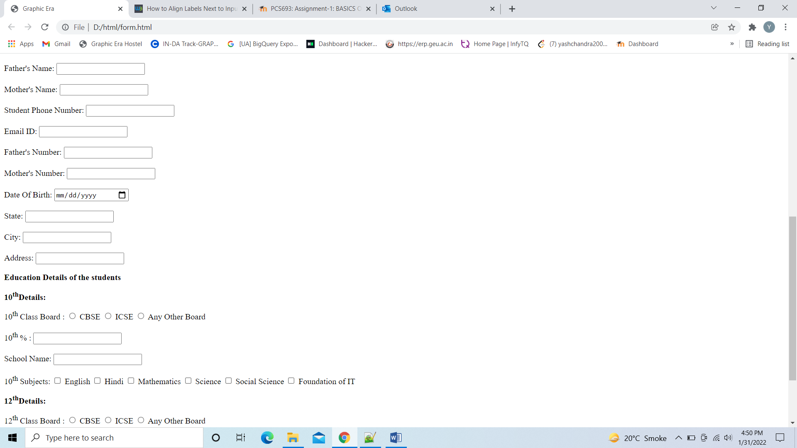

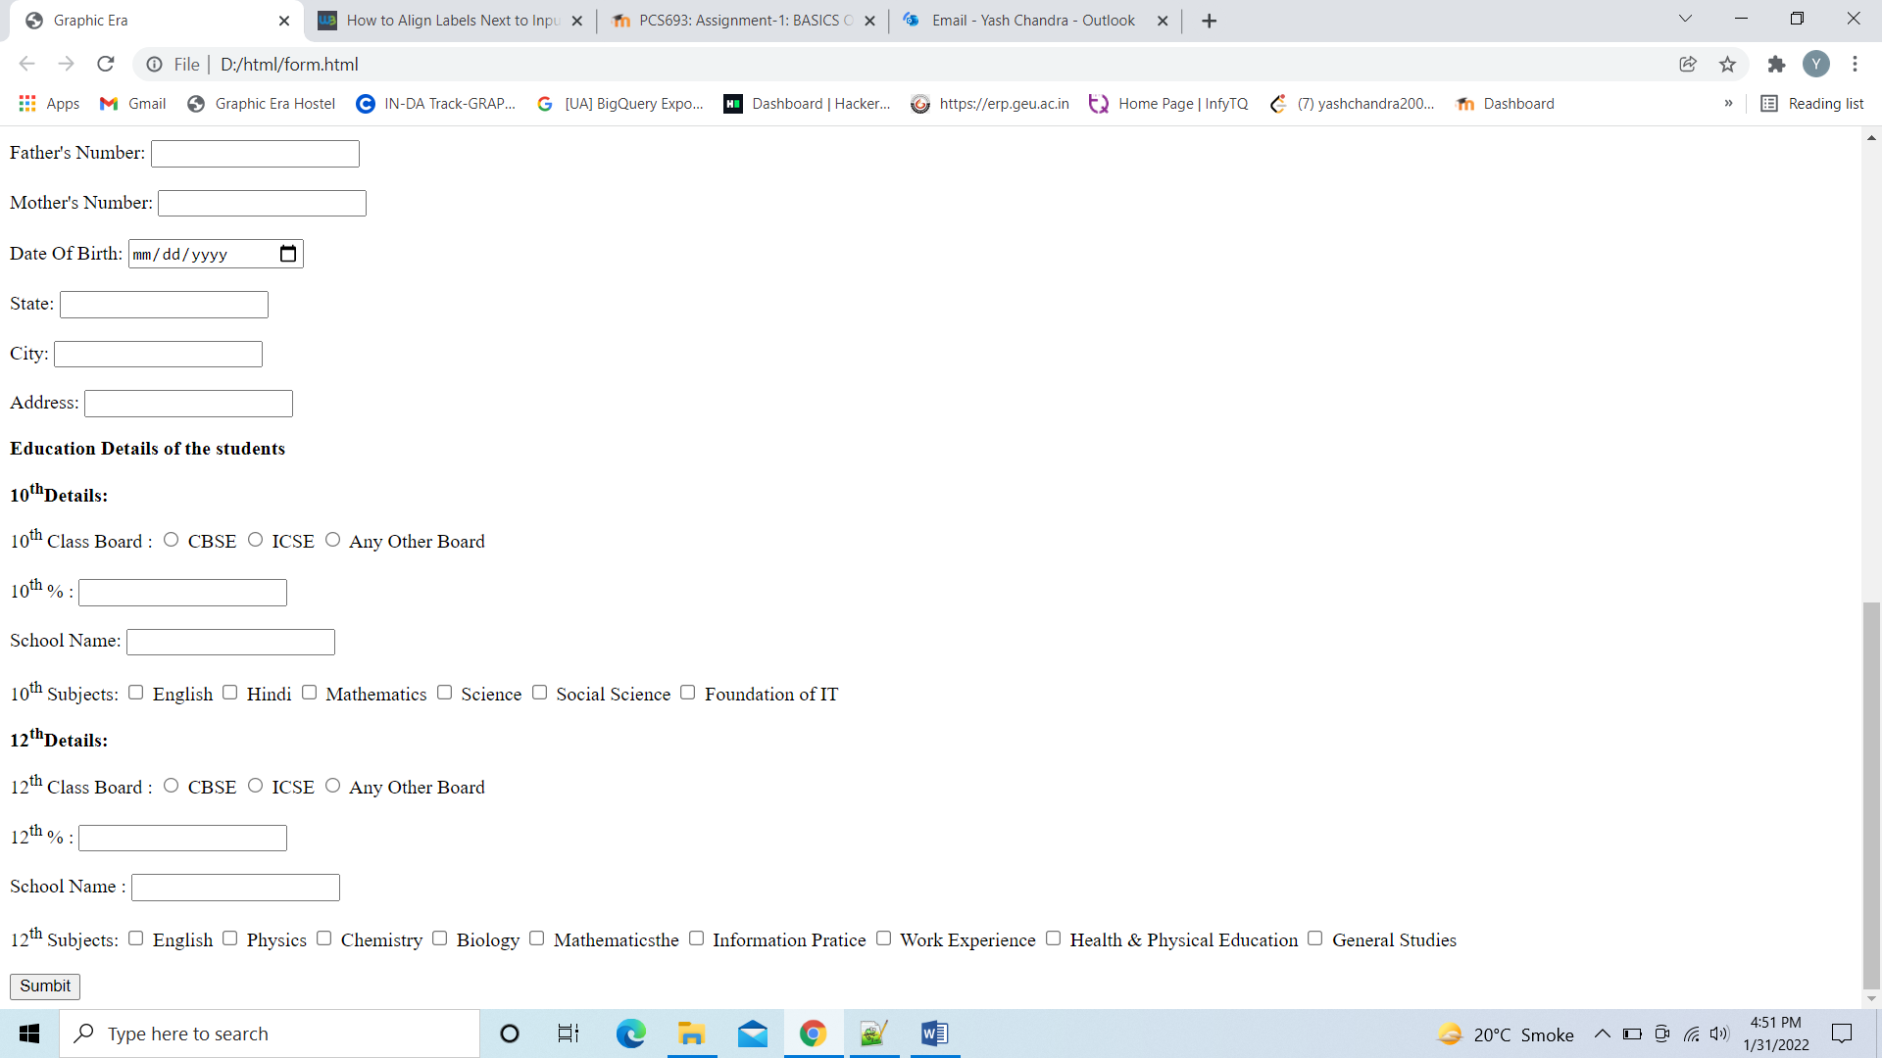

**Question-2** **Write a simple HTML Script to make your Time Table.**

**Answer-2**

Code-2

<!doctype html>

<html>

<head>

<title> Time table</title>

</head>

<body>

<h1 align="center"> Graphic Era Deemed To Be University</h1>

<h2 align="center"> Time Table f B.Tech 6<sup>th</sup> Semester – Computer Science & Engineering (Section - E)</h2>

<h3 align="center">Academic Year 2021-22</h3>

<h4 align="center"> W.E.F:31st January 2022</h4>

<table align="center" border="1x solid">

<tr>

<th> Day</th>

<th>9:00-9:55</th>

<th>9:55-10:50</th>

<th>11:10-12:05</th>

<th>12:05-1:00</th>

<th>1:00-1:55</th>

<th>1:55-2:55</th>

<th>3:10-4:05</th>

<th>4:05-5:00</th>

</tr>

<tr>

<th> Monday</th>

<th bgcolor="red">TCS-602</th>

<th bgcolor="darkmagneta">TCS693</th>

<th bgcolor="Yellow">TCS-601</th>

<th bgcolor="cyan">TCS-691/TCS-651/TCS-619</th>

<th>Lunch</th>

<th>XCS-601(PDP)</th>

<th colspan="2">Career Excellence Classes(CEC)</th>

</tr>

<tr>

<th> Tuesday</th>

<th bgcolor="red">TCS-602</th>

<th bgcolor="darkmagneta">TCS693</th>

<th bgcolor="yellow">TCS-601</th>

<th bgcolor="cyan">TCS-691/TCS-651/TCS-619</th>

<th>Lunch</th>

<th>XCS-601(QAR)</th>

<th bgcolor="lightgreen">TCS-604</th>

<th bgcolor="lightgreen">TCS-604</th>

</tr>

<tr>

<th> Wednesday</th>

<th bgcolor="red">TCS-602</th>

<th bgcolor="darkmagneta">TCS693</th>

<th bgcolor="yellow">TCS-601</th>

<th bgcolor="cyan">TCS-691/TCS-651/TCS-619</th>

<th>Lunch</th>

<th>Lib</th>

<th bgcolor="lightgreen">TCS-604</th>

<th bgcolor="lightgreen">TCS-604(Discussion Class)</th>

</tr>

<tr>

<th> Thursday</th>

<th bgcolor="red">TCS-602(Discussion Class)</th>

<th bgcolor="darkmagneta">TCS693 (Discussion Class)</th>

<th bgcolor="yellow">TCS-601 (Discussion Class)</th>

<th bgcolor="cyan">TCS-691/TCS-651/TCS-619 (Discussion Class)</th>

<th>Lunch</th>

<th colspan="3">SWAYAM/Training/Extra Curricular Activites/LIB</th>

</tr>

<tr>

<th>Friday</th>

<th colspan="2">Software Engineering Lab</th>

<th colspan="2">Complier Design Lab</th>

<th> Lunch</th>

<th>LIB</th>

<th colspan="2">Complier Design Lab </th>

</tr>

</table>

</body>

</html>

**Output-**

